Restaurant website
“KHAO PIYO!”



Software Requirements Specification

15 April 2024

Raghav Gupta
(12215792)

Prepared for
Continuous Assessment 3
Spring 2024

Revision History

Date | Description | Author | Comments
<date> | <Version 1> | <Your Name> | <First Revision>

Table of Contents

Revision History ii
1. Introduction 1
1.1 Purpose 1
1.2 Scope 1
1.3 Definitions, Acronyms, and Abbreviations 1
1.4 References 1
1.5 Overview 1
2. General Description 2
2.1 Product Perspective 2
2.2 Product Functions 2
2.3 User Characteristics 2
2.4 General Constraints 2
2.5 Assumptions and Dependencies 2
3. Specific Requirements 2
3.1 External Interface Requirements 3
3.1.1 User Interfaces 3
3.1.2 Hardware Interfaces 3
3.1.3 Software Interfaces 3
3.1.4 Communications Interfaces 3
3.2 Functional Requirements 3
3.2.1 <Functional Requirement or Feature #1> 3
3.2.2 <Functional Requirement or Feature #2> 3
3.5 Non-Functional Requirements 4
3.5.1 Performance 4
3.5.2 Reliability 4
3.5.3 Availability 4
3.5.4 Security 4
3.5.5 Maintainability 4
3.5.6 Portability 4
3.7 Design Constraints 4
3.9 Other Requirements 4
4. Analysis Models 4
4.1 Data Flow Diagrams (DFD) 5
5. Github link…………………………………………………………………………………………………….5
A. Appendices 5
A.1 Appendix 1 5
A.2 Appendix 2 5

1. Introduction.
The Software Requirements Specification (SRS) document for the "KHAO PIYO!" application encapsulates the essential details required for the development of a food ordering and delivery system. This document aims to provide a comprehensive overview of the software requirements, guiding software engineers in designing and implementing the envisioned application.

1.1 Purpose
The purpose of this Software Requirement Specification (SRS) document is to outline the requirements for the "KHAO PIYO!" application. It serves as a guide for software engineers to understand the project's scope, functionalities, and constraints. Additionally, it facilitates communication among stakeholders by providing a clear overview of the project's objectives. This document is intended to ensure that all parties involved in the project have a comprehensive understanding of its requirements.

1.2 Scope
Software Product(s) Identification
The software product described in this document is the "KHAO PIYO!" application.

Functionality
The software product will:
- Allow users to browse a list of food items.
- Provide detailed information about each food item, including name, image, and price.
- Allow users to add food items to a shopping cart.
- Display a shopping cart with the selected food items.
- Allow users to adjust the quantity of food items in the shopping cart.
- Provide a checkout process to complete the order.

The software product will not:
- Process payments directly within the application.
- Handle user authentication and account management.

Application Description
This software application aims to provide users with a convenient platform to browse and order food items. Its primary objective is to facilitate the selection and purchase of food items from a predefined menu. The application targets users who wish to order food items for takeaway or delivery. It is designed to streamline the ordering process and enhance the user experience by offering a user-friendly interface and efficient navigation. The application's scope aligns with the objectives of providing a seamless food ordering experience while excluding features related to payment processing and user management, which may be handled by external systems or services.

1.3 Definitions, Acronyms, and Abbreviations

- SRS: Software Requirement Specification - A document that outlines the functional and non-functional requirements of a software system.
- HTML: HyperText Markup Language - A standard markup language for creating web pages and web applications.
- CSS: Cascading Style Sheets - A style sheet language used for describing the presentation of a document written in HTML.
- JS: JavaScript
- JSON: JavaScript Object Notation - A lightweight data-interchange format that is easy for humans to read and write, and easy for machines to parse and generate.
- API: Application Programming Interface - A set of rules and protocols for building and interacting with software applications.
- UI: User Interface - The visual elements and interactive components of a software application that users interact with.
- UX: User Experience - The overall experience of a user when interacting with a product or system, encompassing usability, accessibility, and satisfaction.
- HTTP: Hypertext Transfer Protocol - An application protocol for distributed, collaborative, hypermedia information systems.
- UPI: Unified Payments Interface

1.4 References

- [W3Schools] (https://www.w3schools.com/ )
- [MDN Web Docs] (https://developer.mozilla.org/ )
- [Formspree] (https://formspree.io/ )
- [Font Awesome] (https://fontawesome.com/ )
- [Unsplash] (https://unsplash.com/ )

1.5 Overview
The restaurant website aims to provide a seamless and enjoyable experience for users to explore menu items, place orders, and interact with the restaurant. It leverages modern web technologies such as HTML, CSS, and JavaScript to create an engaging and responsive interface. Additionally, the integration of third-party services such as Formspree for feedback and Font Awesome for icons enhances the website's functionality and visual appeal. Overall, the website seeks to meet the needs of both customers and the restaurant staff, facilitating efficient operations and customer satisfaction.

2. General Description

This section provides an overview of the project's overarching factors and requirements without specifying detailed requirements.

2.1 Product Perspective
- It entails understanding the project's position within the broader landscape of similar services.
- Comparison with competitors, integration possibilities, and differentiation factors are considered.

2.2 Product Functions
- Summarizes core functionalities, including
- browsing menus,
- placing orders,
- processing payments,
- viewing order history.
- Feedback and review features are also included.

2.3 User Characteristics
- Demographics, technological proficiency, and behavior patterns of users are described.
- Factors such as age, location, comfort with online systems, and ordering habits are considered.

2.4 General Constraints
- Technological, regulatory, and budgetary limitations are outlined.
- Constraints may include compatibility issues, compliance requirements, and resource limitations

2.5 Assumptions and Dependencies
- Lists factors like availability of third-party APIs, reliability of internet connectivity, and dependencies on external systems.
- These factors can influence project requirements and implementation strategies.

3. Specific Requirements

3.1 External Interface Requirements
This section delineates the external interfaces necessary for the proper functioning of the software system. These interfaces include user interfaces, hardware interfaces, software interfaces, and communication interfaces

3.1.1 User Interfaces
- The user interfaces refer to the visual and interactive components through which users interact with the software.
- The HTML and CSS code provided in the project contain the structure and styling for user interfaces such as:
- payment forms, feedback forms
- product listings
- shopping cart displays.

3.1.2 Hardware Interfaces
- Hardware interfaces refer to the connections and interactions between the software system and hardware components.
- Potential hardware interfaces may include interactions with devices such as scanners, printers, or payment terminals for processing transactions.

3.1.3 Software Interfaces
- Software interfaces specify how the software system interacts with other software components or systems.
- The JavaScript code provided in the project orchestrates interactions between different parts of the software system, such as handling user inputs, updating cart contents, and managing product data.

3.1.4 Communications Interfaces
- Communications interfaces outline the protocols and methods used for communication between the software system and external entities.
- In the project, communication interfaces may include interactions with external servers or APIs for tasks such as fetching product data, processing payments, or sending feedback submissions.

These external interface requirements ensure seamless interaction between the software system and its users, hardware components, other software systems, and external communication channels.

3.2 Functional Requirements
This section outlines the specific features and functionalities of the software project. Each functional requirement or feature is described in detail, including its introduction, inputs, processing, outputs, and error handling.

3.2.1 Payment Processing Feature
3.2.1.1 Introduction
- HTML and CSS code define the payment success page layout and styling.
- JavaScript code handles the payment processing functionality, including redirecting users to the success page upon successful payment.

3.2.1.2 Inputs
- Input fields for UPI ID are defined in the HTML code, allowing users to enter their
payment information.

3.2.1.3 Processing
- JavaScript code listens for the click event on the "Pay Now" button and redirects users
to the success page upon successful payment processing.

3.2.1.4 Outputs
- HTML code defines the structure and content of the payment success page, including
the confirmation message.

3.2.1.5 Error Handling
- JavaScript code includes error handling mechanisms to handle and display error
messages to users if payment processing fails.

3.2.2 Add to Cart Feature
- JavaScript code handles the functionality of adding items to the cart and updating the
cart contents.

3.2.3 View Cart Feature

3.2.3.1 Introduction
- JavaScript code manages the functionality of displaying the cart contents to users and
updating the cart dynamically.

3.2.3.2 Inputs
- HTML and CSS define the structure and styling of the cart interface, while JavaScript
handles user interactions and updates to the cart display.

3.2.3.3 Processing
- JavaScript functions handle the processing of user actions, such as clicking on the cart
icon, and dynamically update the cart display with the current items.

3.2.3.4 Outputs
- HTML code generates the cart display based on the current contents of the cart, while
CSS styles ensure a visually appealing presentation.

3.2.3.5 Error Handling
- JavaScript code includes error handling functionality to detect and handle errors,
ensuring a smooth user experience when interacting with the cart interface.

3.2.4 Update Cart Feature

- JavaScript functions manage the functionality of updating the cart contents based
on user actions, such as increasing or decreasing item quantities or removing items.

3.5 Non-Functional Requirements

3.5.1 Performance
- The system shall render the product list within 2 seconds of the user's request, ensuring a responsive user interface.
- Adding items to the shopping cart shall have a response time of less than 1 second under normal operating conditions, enhancing user experience during the shopping process.
- The system shall support concurrent user sessions, with a minimum capacity of 100 simultaneous users, maintaining performance without significant degradation.

3.5.2 Reliability
- The system shall maintain an uptime of at least 99% over a 30-day period, ensuring reliable access to users.
- Regular backups of product data and user information shall be performed with a frequency of at least once per day to prevent data loss in the event of system failure.
- In case of system failure, the system shall have a recovery mechanism to restore to a stable state within 5 minutes without compromising data integrity.

3.5.3 Availability
- The system shall be available 24/7, with planned maintenance scheduled during off-peak hours to minimize disruption to users.
- Critical system components shall have a Mean Time Between Failures (MTBF) exceeding 30 days, ensuring high availability and reliability of the system

3.5.4 Security
- User authentication mechanisms, including password encryption and protection against brute force attacks, shall be implemented to ensure secure access to the system.
- User data, including personal information and payment details, shall be encrypted during transmission and storage to prevent unauthorized access and ensure data confidentiality.
- Access to administrative functions shall be restricted to authorized personnel through role-based access control (RBAC), preventing unauthorized access to sensitive system features.

3.5.5 Maintainability
- The system shall be modularized and well-documented to facilitate ease of maintenance and future enhancements by development teams.
- Version control systems shall be utilized to track code changes and updates, maintaining a history of revisions and enabling collaboration among developers.

3.5.6 Portability
- The system shall be compatible with modern web browsers, including Google Chrome, Mozilla Firefox, and Safari, ensuring accessibility across different platforms and devices.
- Mobile responsiveness shall be implemented to optimize the user experience on smartphones and tablets, allowing users to access the system seamlessly from various devices.

3.7 Design Constraints

- Compatibility Requirement: The software must be compatible with modern web browsers, including Chrome, Firefox, Safari, and Edge, ensuring consistent performance and user experience across different platforms.

- Responsive Design: The user interface must be responsive and adaptable to various screen sizes, including desktops, tablets, and mobile devices, to accommodate a wide range of users and usage scenarios.

- Data Security: The system must adhere to industry-standard data security protocols, such as encryption of sensitive information during transmission and storage, to protect user data from unauthorized access or breaches.

- Scalability: The software architecture must be designed to scale efficiently, allowing for increased user load and data volume without compromising performance or stability, to accommodate future growth and expansion.

- Regulatory Compliance: The system must comply with relevant regulations and standards, including GDPR (General Data Protection Regulation) and PCI DSS (Payment Card Industry Data Security Standard), to ensure the privacy and security of user data and financial transactions.

- Accessibility: The user interface must be accessible to users with disabilities, complying with accessibility standards such as WCAG (Web Content Accessibility Guidelines), to ensure equal access and usability for all users.

- Third-Party Integration: The software must support integration with external services or APIs, such as payment gateways or third-party plugins, to extend functionality and provide additional features to users.

- Technology Stack: The software development must utilize a specific technology stack, including HTML, CSS, JavaScript, and any relevant frameworks or libraries, to ensure consistency and maintainability of the codebase.

3.9 Other Requirements

- Documentation: Comprehensive documentation must be provided for the software, including user manuals, developer guides, and API documentation, to facilitate understanding, usage, and maintenance of the system.

- Training: Training sessions must be conducted for end-users and administrators to familiarize them with the software's features, functionalities, and best practices for optimal utilization.

- Support and Maintenance: Ongoing technical support and maintenance services must be available to address user inquiries, resolve issues, and perform software updates or patches to ensure the system's reliability and performance.

- Backup and Recovery: Regular backups of user data must be performed to prevent data loss in the event of system failure or corruption, with provisions for efficient data recovery procedures to restore the system to a functional state.

- Performance Monitoring: Monitoring tools must be implemented to track system performance metrics, including response time, throughput, and resource utilization, to identify and address performance bottlenecks or issues proactively.

- Version Control: Version control systems, such as Git, must be utilized to manage the source code repository, enabling collaborative development, code review, and version tracking to maintain code integrity and facilitate teamwork.

- Change Management: Formal change management processes must be established to manage modifications or updates to the software, including requirements changes, feature enhancements, or bug fixes, ensuring proper documentation, testing, and approval before implementation.

- User Feedback: Mechanisms for collecting user feedback and suggestions must be implemented to gather insights into user experiences, preferences, and feature requests, enabling continuous improvement and refinement of the software based on user input..

4. Analysis Models
Analysis models are essential for understanding and visualizing the system's behavior and interactions. The following analysis models are used in developing specific requirements outlined in this SRS:

4.1 Data Flow Diagrams (DFD)

Zero level DFD (Context Diagram):

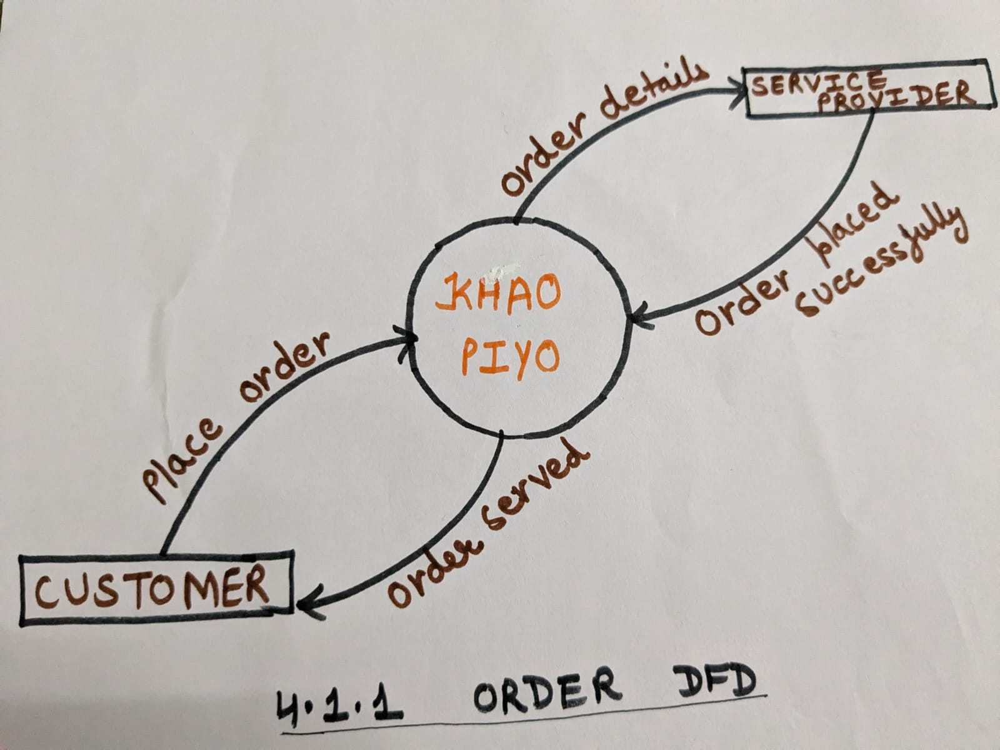

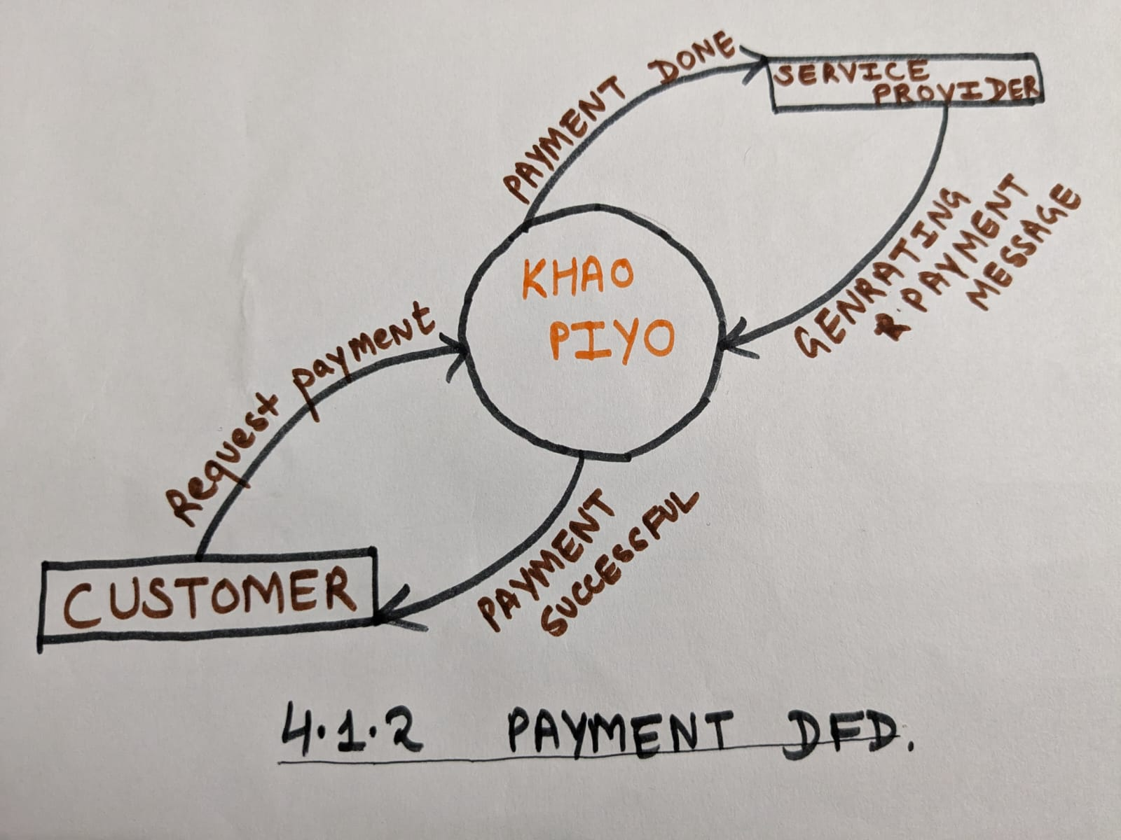

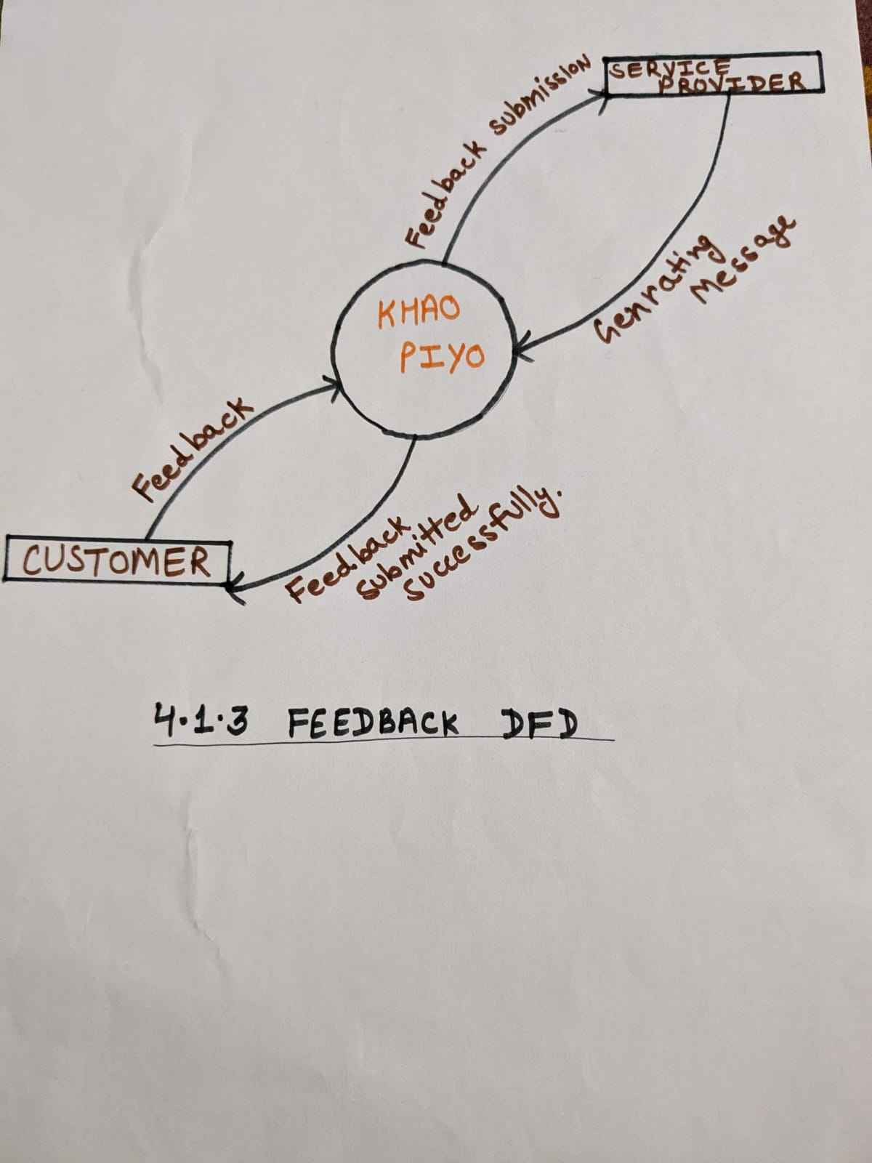

6. GitHub Link
https://github.com/Raghavgupta2003

A. Appendices
Appendices may include supplementary information that enhances understanding or provides context for the software project. It is important to clarify whether the information in the appendices is considered part of the SRS's overall set of requirements.

A.1 Appendix 1: Conceptual Documents
This appendix contains conceptual documents related to the software project. It includes initial sketches, diagrams, or concept maps that outline the overall structure and functionality of the system. These documents provide stakeholders with a high-level understanding of the project's goals and objectives.

A.2 Appendix 2: Meeting Minutes
This appendix comprises minutes of meetings held with the customer(s) during the requirements gathering and analysis phase. It documents discussions, decisions, and action items arising from these meetings. The meeting minutes serve as a record of stakeholder input and provide insight into the evolution of project requirements and priorities.

